

FOOD ORDERING SYSTEM IN RAILWAYS

RIA CHANDRA (21BIT0438)

SOHAM THORAT (21BIT0503)

CHIRAG VATS (21BIT0516)

**CODE:**

**<html>**

**<head>**

**<meta charset="UTF-8">**

**<meta name="viewport" content= "width=device-width, initial-scale=1.0">**

**<title>login</title>**

**<style>**

**.container**

**{**

**display : flex;**

**width : 600px;**

**height : 650px;**

**background-color : white;**

**justify-content : center;**

**text-color : black;**

**opacity : 0.7;**

**}**

**.container2{**

**display : flex;**

**width : 600px;**

**height : 400px;**

**background-color : white;**

**justify-content : center;**

**opacity : 0.6;**

**margin : 120px;**

**border : solid;**

**border-color : white;**

**border-width : 8px;**

**}**

**.item**

**{**

**background-color : black;**

**width : 200 px ;**

**height : 400px;**

**margin : 140px;**

**padding : 20px;**

**border: #ff7a59 solid 3px;**

**color : white;**

**}**

**a:link{**

**color : white;**

**}**

**a:visited{**

**color:white;**

**}**

**a:hover{**

**color : red;**

**}**

**.button {**

**border: none;**

**background: white;**

**color: black;**

**padding: 10px;**

**position: relative;**

**box-sizing: border-box;**

**}**

**.button:hover{**

**color: white;**

**border: #ff7a59 solid 1px;**

**background:black;**

**}**

**marquee {**

**background: #333;**

**margin: 30px auto;**

**display: block;**

**color: #fff;**

**}**

**.ticker-left li {**

**display: inline-block;**

**font-size: 18px;**

**line-height: 40px;**

**}**

**</style>**

**<script src = "https://ajax.googleapis.com/ajax/libs/jquery/3.6.1/jquery.min.js"></script>**

**<script>**

**$(document).ready(function(){**

**$("#uname").focus(function(){**

**$(this).css("background-color","#FFE5B4");**

**});**

**$("#uname").blur(function(){**

**$(this).css("background-color","lightgreen");**

**});**

**});**

**$(document).ready(function(){**

**$("#passw").focus(function(){**

**$(this).css("background-color","#FFE5B4");**

**});**

**$("#passw").blur(function(){**

**$(this).css("background-color","lightgreen");**

**});**

**});**

**function validateForm(){**

**var name = document.getElementById("uname");**

**var passw = document.getElementById("passw");**

**var uname = document.forms["form1"]["uname"].value;**

**if(name.validity.patternMismatch){**

**alert("Please enter a valid username");**

**return false;**

**}**

**if(passw.validity.patternMismatch){**

**alert("Please enter valid password");**

**return false;**

**}**

**if (uname == "")**

**{**

**alert("Please input a Value");**

**return false;**

**}**

**}**

**</script>**

**</head>**

**<body background = "D:\VIT\sem 4\WEB TECH\projects\bg.avif">**

**<div class = "container2" style = "float: left">**

**<img src = "D:\chrome downloads\station-7767132.jpg" style = "width : 100%; height : 100%">**

**</div>**

**<div class = "container" style = "margin-left: 60%">**

**<div class = "item">**

**<h2 style = "text-align : center; background-color: neon green"><u><b>LOGIN</u></b></h2><br>**

**<form action ="D:\VIT\sem 4\WEB TECH\projects\Frames.html" name = "form1">**

**<br><b>USERNAME :&nbsp</b><input type = "text" name = uname placeholder = "enter your username" id = "uname" pattern = "[A-Za-z]{1,30}"></input><br><br>**

**<br><b>PASSWORD :&nbsp</b><input type = "password" name = passw placeholder = "password" id = "passw" pattern="(?=.*\d)(?=.*[a-z])(?=.*[A-Z]).{8,}"></input><br><br><br>**

**<p style = "text-align:center"><input class = "button" type = submit onclick = "validateform()" value = "LOGIN"></input></p>**

**<br><b><a href = "D:\VIT\sem 4\WEB TECH\projects\forget_pass.html" style = "font-family: garamond">Forget password?</b></a><br>**

**<br><b><a href = "D:\VIT\sem 4\WEB TECH\projects\signup.html" style = "font-family: garamond">Sign up</b></a>**

**</form>**

**</div>**

**</div>**

**<marquee direction="left" height="40px" width="1200px" scrollamount="5" onmouseover="this.stop();" onmouseout="this.start();">**

**<ul class="ticker-left" style="margin:auto">**

**<li>welcome to our site!!!**

**</li>**

**<li>best food!!!</li>**

**<li>fast service!!!</li>**

**<li>lowest price!!!</li>**

**</marquee>**

**</body>**

**</html>**

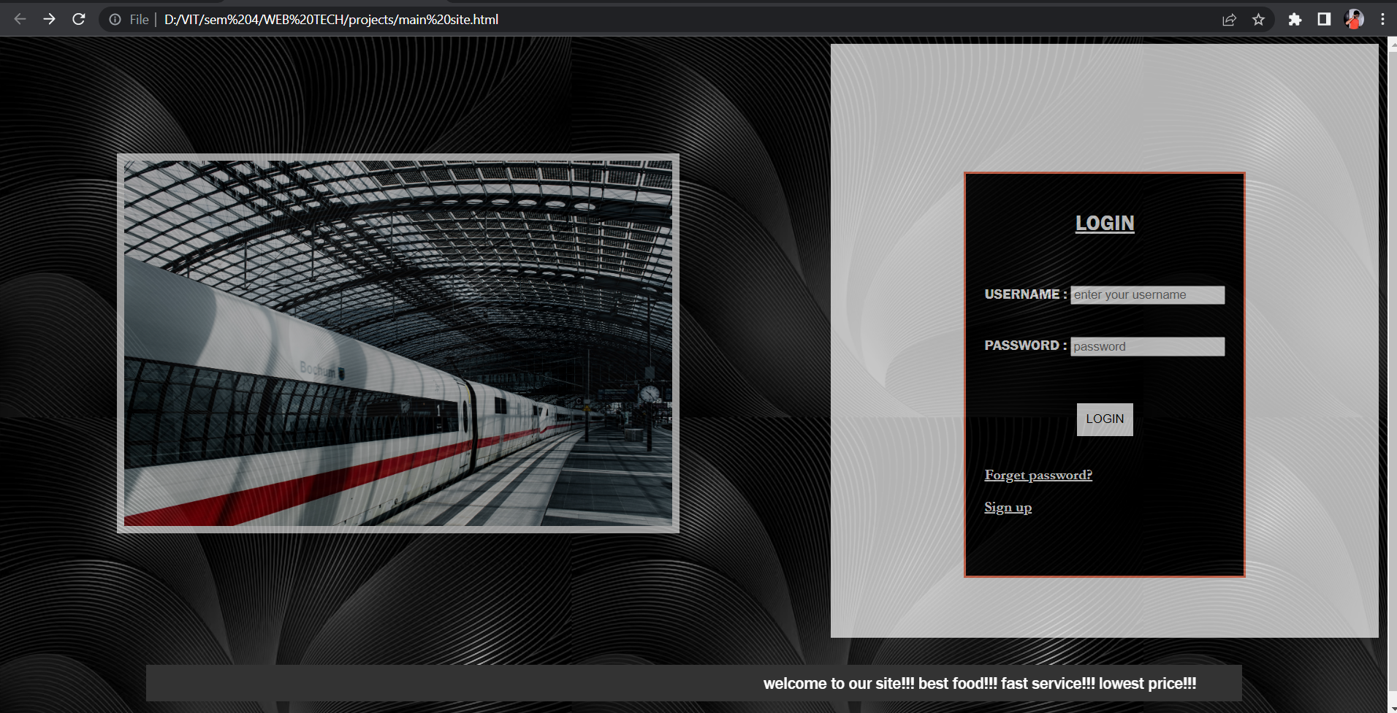

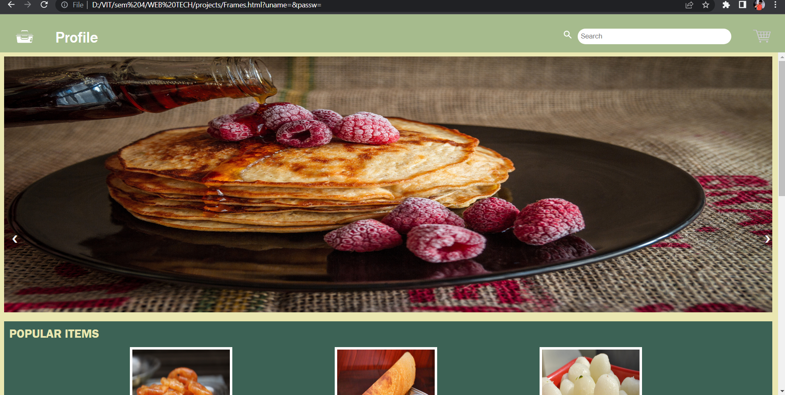

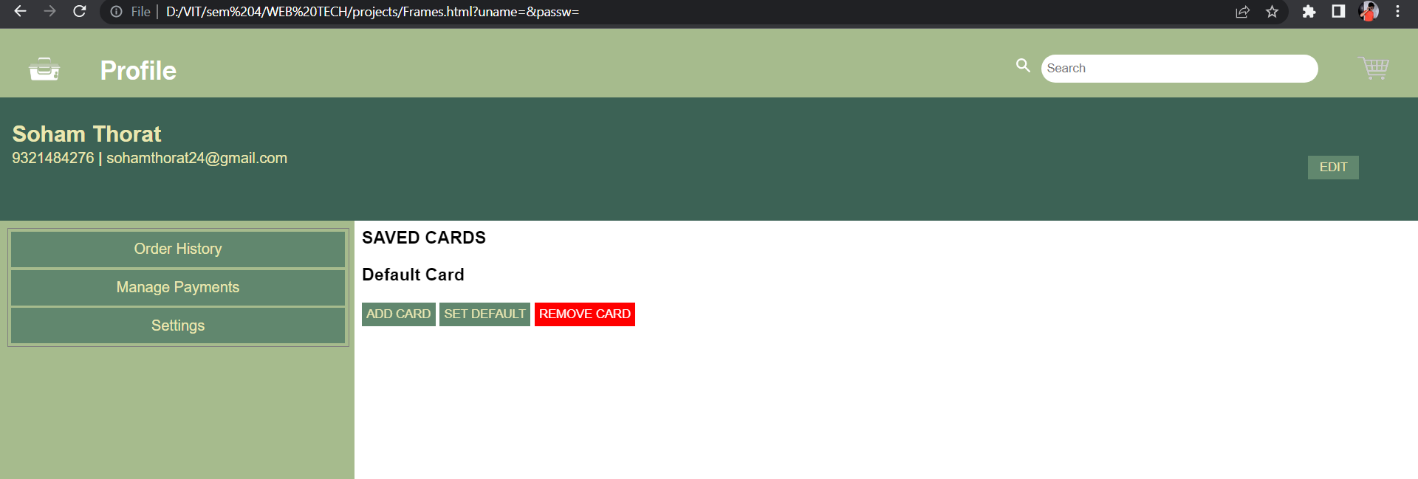

**<!DOCTYPE html>**

**<html>**

**<head>**

**<script src="https://ajax.googleapis.com/ajax/libs/jquery/3.6.1/jquery.min.js"></script>**

**<script>**

**$(document).ready(function(){**

**var data_appy = 1;**

**var data = 1;**

**document.getElementById("counting_appy").innerText = data_appy;**

**$("#9").click(function(){**

**data_appy = data_appy + 1;**

**document.getElementById("counting_appy").innerText = data_appy;**

**});**

**$("#7").click(function(){**

**if(data_appy==1){**

**if(confirm("Item will be removed from the cart!!")==true){**

**text = "Item removed!!";**

**}**

**else{**

**text = "you canceled!";**

**}**

**}**

**else{**

**data_appy = data_appy - 1;**

**document.getElementById("counting_appy").innerText = data_appy;**

**}**

**});**

**document.getElementById("counting").innerText = data;**

**$("#20").click(function(){**

**data = data + 1;**

**document.getElementById("counting").innerText = data;**

**});**

**$("#19").click(function(){**

**if(data==1){**

**if(confirm("Item will be removed from the cart!!")==true){**

**text = "Item removed!!";**

**}**

**else{**

**text = "you canceled!";**

**}**

**}**

**else{**

**data = data - 1;**

**document.getElementById("counting").innerText = data;**

**}**

**});**

**$(".remove").click(function(){**

**$("#1").remove();**

**});**

**$(".Action").click(function(){**

**console.log("abc");**

**$(".Cart-Items").remove();**

**});**

**});**

**</script>**

**</head>**

**<style>**

**body{**

**margin: 0;**

**padding: 0;**

**background-color: #3C6255;**

**height: 100vh;**

**display: flex;**

**justify-content: center;**

**align-items: center;**

**}**

**.Cart-Container{**

**width: 70%;**

**height: 85%;**

**background-color: #A6BB8D;**

**border-radius: 20px;**

**box-shadow: 0px 10px 20px #E6E5A3;**

**}**

**.Header{**

**margin: auto;**

**width: 90%;**

**height: 15%;**

**display: flex;**

**justify-content: space-between;**

**align-items: center;**

**}**

**.Heading{**

**font-size: 20px;**

**font-family: ‘Open Sans’;**

**font-weight: 700;**

**color: #2F3841;**

**}**

**.Action{**

**font-size: 14px;**

**font-family: ‘Open Sans’;**

**font-weight: 600;**

**color: #E44C4C;**

**cursor: pointer;**

**border-bottom: 1px solid #E44C4C;**

**}**

**.Cart-Items{**

**margin: auto;**

**width: 90%;**

**height: 30%;**

**display: flex;**

**justify-content: space-between;**

**align-items: center;**

**}**

**.image-box{**

**width: 15%;**

**text-align: center;**

**}**

**.about{**

**height: 70%;**

**}**

**.title{**

**padding-top: 5px;**

**line-height: 10px;**

**font-size: 32px;**

**font-family: ‘Open Sans’;**

**font-weight: 800;**

**color: #202020;**

**}**

**.subtitle{**

**line-height: 10px;**

**font-size: 18px;**

**font-family: ‘Open Sans’;**

**font-weight: 600;**

**color: #909090;**

**}**

**.counter{**

**width: 15%;**

**display: flex;**

**justify-content: space-between;**

**align-items: center;**

**}**

**.btn{**

**width: 40px;**

**height: 40px;**

**border-radius: 50%;**

**background-color: #EAE7B1;**

**display: flex;**

**justify-content: center;**

**align-items: center;**

**font-size: 20px;**

**font-family: ‘Open Sans’;**

**font-weight: 900;**

**color: #202020;**

**cursor: pointer;**

**}**

**.count{**

**font-size: 20px;**

**font-family: ‘Open Sans’;**

**font-weight: 900;**

**color: #202020;**

**}**

**.prices{**

**height: 50%;**

**text-align: right;**

**}**

**.amount{**

**padding-top: 20px;**

**font-size: 26px;**

**font-family: ‘Open Sans’;**

**font-weight: 800;**

**color: #202020;**

**}**

**.remove{**

**padding-top: 5px;**

**font-size: 14px;**

**font-family: ‘Open Sans’;**

**font-weight: 600;**

**color: #E44C4C;**

**cursor: pointer;**

**}**

**hr{**

**width: 66%;**

**float: right;**

**margin-right: 5%;**

**}**

**.checkout{**

**float: right;**

**margin-right: 5%;**

**width: 28%;**

**}**

**.total{**

**width: 100%;**

**display: flex;**

**justify-content: space-between;**

**}**

**.Subtotal{**

**font-size: 22px;**

**font-family: ‘Open Sans’;**

**font-weight: 700;**

**color: #202020;**

**}**

**.items{**

**font-size: 16px;**

**font-family: ‘Open Sans’;**

**font-weight: 500;**

**color: #909090;**

**line-height: 10px;**

**}**

**.total-amount{**

**font-size: 36px;**

**font-family: ‘Open Sans’;**

**font-weight: 900;**

**color: #202020;**

**}**

**.button{**

**margin-top: 5px;**

**width: 100%;**

**height: 40px;**

**border: none;**

**background-color: #EAE7B1;**

**border-radius: 20px;**

**cursor: pointer;**

**font-size: 16px;**

**font-family: ‘Open Sans’;**

**font-weight: 600;**

**color: #202020;**

**}**

**</style>**

**<body>**

**<div class="Cart-Container">**

**<div class="Header">**

**<h3 class="Heading">Shopping Cart</h3>**

**<h5 class="Action">Remove all</h5>**

**</div>**

**<div class="Cart-Items" id ="1">**

**<div class="image-box" id ="2">**

**<img src="D:\VIT\sem 4\WEB TECH\projects\apple_juice-removebg-preview.png" style={{ height="120px" }} />**

**</div>**

**<div class="about" id ="3">**

**<h1 class="title" id ="4">Apple Juice</h1>**

**<h3 class="subtitle" id ="5">Quantity: 250ml</h3>**

**<img src="D:\VIT\sem 4\WEB TECH\projects\veg.jpeg"style={{ height="30px" }}/>**

**</div>**

**<div class="counter" id ="6">**

**<button class="btn" id ="7">-</button>**

**<h2 id="counting_appy" id ="8">1</h2>**

**<button class="btn" id ="9">+</button>**

**</div>**

**<div class="prices" id ="10">**

**<div class="amount" id ="11">Rs.40</div>**

**<div class="remove" id="12"><u>Remove</u></div>**

**</div>**

**</div>**

**<div class="Cart-Items" id ="13">**

**<div class="image-box" id ="14">**

**<img src="D:\VIT\sem 4\WEB TECH\projects\burger.png" style={{ height="120px" }} />**

**</div>**

**<div class="about" id="15">**

**<h1 class="title" id ="16">Tripple Cheeseburger</h1>**

**<h3 class="subtitle" id="17">Quantity: 1</h3>**

**<img src="D:\VIT\sem 4\WEB TECH\projects\veg.jpeg" style={{ height="30px" }}/>**

**</div>**

**<div class="counter" id ="18">**

**<button class="btn" id ="19">-</button>**

**<h2 id="counting">1</h2>**

**<button class="btn" id="20">+</button>**

**</div>**

**<div class="prices" id ="21">**

**<div class="amount" id="22">Rs.215</div>**

**<div class="remove" id="23"><u>Remove</u></div>**

**</div>**

**</div>**

**<hr>**

**<div class="checkout" id ="24">**

**<div class="total" id ="25">**

**<div>**

**<div class="Subtotal" id ="26">Sub-Total</div>**

**<div class="items" id ="27">2 items</div>**

**</div>**

**<div class="total-amount" id ="28">Rs. 255</div>**

**</div>**

**<a href="D:\VIT\sem 4\WEB TECH\projects\delivery_details.html">Checkout</a>**

**</div>**

**</div>**

**<**

**</body>**

**</html>**

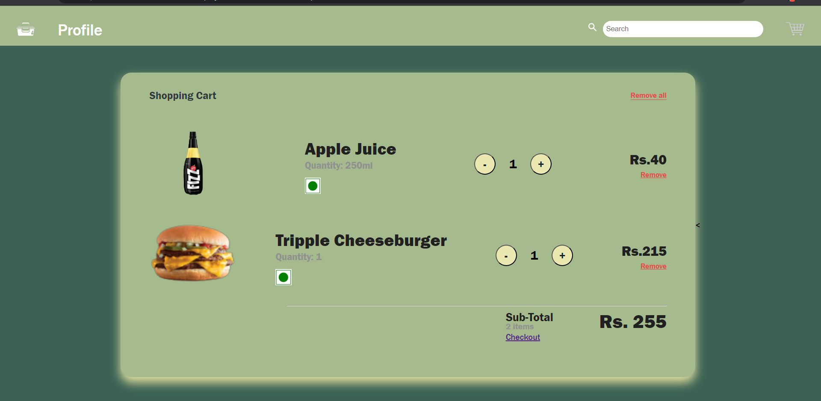

**<html>**

**<head>**

**<title>order_pay</title>**

**<style>**

**.container1{**

**display: flex;**

**height: 700px;**

**width : 1000px;**

**background-color: #61876E;**

**margin:auto;**

**border-radius: 20px;**

**box-shadow: 0px 25px 40px grey;**

**}**

**.flexitem{**

**display:flex;**

**height: 700px;**

**width:500px;**

**background-color: #A6BB8D;**

**border-radius: 20px;**

**box-shadow: 0px 25px 40px grey;**

**flex-direction:column;**

**}**

**.flexitem3{**

**display:flex;**

**height: 700px;**

**width:500px;**

**background-color: #A6BB8D;**

**border-radius: 20px;**

**box-shadow: 0px 25px 40px grey;**

**flex-direction:column;**

**}**

**.flexitem2{**

**display:flex;**

**height: 15%;**

**width:490px;**

**margin:5px;**

**background-color: #EAE7B1;**

**border-radius: 20px;**

**box-shadow: 0px 25px 40px grey;**

**}**

**.image-box{**

**display:flex;**

**height: 15%;**

**width:100px;**

**margin:5px;**

**background-color: #EAE7B1;**

**}**

**.about{**

**display:flex;**

**height: 15%;**

**width:300px;**

**margin:30px;**

**background-color: #EAE7B1;**

**}**

**.price{**

**display:flex;**

**height: 15%;**

**width:90px;**

**margin:50px;**

**background-color: #EAE7B1;**

**}**

**.final{**

**display:flex;**

**height: 30%;**

**width:490px;**

**margin:auto;**

**background-color: #EAE7B1;**

**border-radius: 20px;**

**box-shadow: 0px 25px 40px grey;**

**}**

**.finals{**

**display:flex;**

**height: 10%;**

**width:245px;**

**margin:5px;**

**background-color: #EAE7B1;**

**border-radius: 20px;**

**}**

**.btn{**

**border: none;**

**width: 30px;**

**height: 20px;**

**background: white;**

**color: black;**

**}**

**marquee {**

**background: #EAE7B1;**

**margin: 5px;**

**display: block;**

**color: black;**

**border-radius: 20px;**

**box-shadow: 0px 25px 40px grey;**

**}**

**.ticker-left li {**

**display: inline-block;**

**font-size: 18px;**

**line-height: 40px;**

**}**

**</style>**

**<script src = "https://ajax.googleapis.com/ajax/libs/jquery/3.6.1/jquery.min.js"></script>**

**<script>**

**$(document).ready(function(){**

**$("#but").click(function(){**

**$(".final").slideToggle("slow");**

**});**

**});**

**$(document).ready(function(){**

**$("#rupay").hide()== true;**

**$("#drop").change(function(){**

**if($("#drop").val()=="RUPAY"){**

**$("#rupay").show();**

**$("#visa").hide()=true;**

**}**

**});**

**$("#drop").change(function(){**

**if($("#drop").val()=="VISA"){**

**$("#visa").show();**

**$("#rupay").hide()=true;**

**}**

**});**

**});**

**$(document).ready(function(){**

**$("#cd").hide();**

**$("#paym").hide();**

**$("#visa").hide();**

**$("#carddet").hide();**

**$("#cardhold").hide();**

**$("#exp").hide();**

**$("#cvc").hide();**

**$("#upii").hide();**

**$("#upip").hide();**

**$("#card").click(function(){**

**$("#paym").show();**

**$("#visa").show();**

**$("#carddet").show();**

**$("#cardhold").show();**

**$("#exp").show();**

**$("#cvc").show();**

**$("#upii").hide();**

**$("#upip").hide();**

**$("#rupay").hide();**

**});**

**$("#upi").click(function(){**

**$("#upii").show();**

**$("#cd").hide();**

**$("#paym").hide();**

**$("#visa").hide();**

**$("#carddet").hide();**

**$("#cardhold").hide();**

**$("#exp").hide();**

**$("#cvc").hide();**

**$("#upip").show();**

**$("#rupay").hide();**

**});**

**});**

**function confirm(){**

**alert("your order has been confirmed");**

**window.location.replace("D:\\VIT\\sem 4\\WEB TECH\\projects\\slider.html");**

**}**

**</script>**

**</head>**

**<body bgcolor = "#3C6255">**

**<div class = "container1">**

**<div class = "flexitem">**

**<marquee direction="left" height="40px" width="490px">**

**<ul class = "ticker-left" style="margin:auto">**

**<li>Order Summary</li>**

**</ul>**

**</marquee><br>**

**<div class = "flexitem2">**

**<div class = "image-box">**

**<img src ="D:\VIT\sem 4\WEB TECH\projects\apple_juice-removebg-preview.png" style="height:90px;">**

**</div>**

**<p class = "about">Appyy Fizz<br>**

**Quantity - 100ml</p>**

**<p class ="price" id ="1">Rs.200</p>**

**</div>**

**<div class = "flexitem2">**

**<div class = "image-box">**

**<img src ="D:\VIT\sem 4\WEB TECH\projects\burger.png" style="height:70px; width:45px; margin:10px">**

**</div>**

**<p class = "about">Cheese Burger<br>**

**Quantity - 1</p>**

**<p class ="price" id="2">Rs.500</p>**

**</div>**

**<div class = "flexitem2">**

**<div class = "image-box">**

**<img src ="D:\VIT\sem 4\WEB TECH\projects\dosa_bg-removebg-preview.png" style="height:90px; width:60px; margin:5px">**

**</div>**

**<p class = "about">Masala Dosa<br>**

**Quantity - 1</p>**

**<p class ="price" id="3">Rs.100</p>**

**</div><br><br>**

**<button style="background-color: #A6BB8D;border-radius: 20px;box-shadow: 0px 25px 40px grey;" id="but">Total</button>**

**<div class = "final">**

**<table style="margin:auto; width:100%; height:100%">**

**<tr>**

**<td><p>&nbsp;&nbsp;&nbsp;&nbsp;&nbsp;&nbsp;&nbsp;&nbsp;&nbsp;&nbsp;CGST(2.5%)&nbsp;&nbsp;&nbsp;&nbsp;-</p></td>**

**<td><p>&nbsp;&nbsp;&nbsp;&nbsp;&nbsp;&nbsp;&nbsp;&nbsp;&nbsp;&nbsp;&nbsp;&nbsp;Rs.20</p>**

**</td>**

**</tr>**

**<tr>**

**<td><p>&nbsp;&nbsp;&nbsp;&nbsp;&nbsp;&nbsp;&nbsp;&nbsp;&nbsp;&nbsp;SGST(2.5%)&nbsp;&nbsp;&nbsp;&nbsp;-</p></td>**

**<td><p>&nbsp;&nbsp;&nbsp;&nbsp;&nbsp;&nbsp;&nbsp;&nbsp;&nbsp;&nbsp;&nbsp;&nbsp;Rs.20</p>**

**</td>**

**</tr>**

**<tr>**

**<td><p>&nbsp;&nbsp;&nbsp;&nbsp;&nbsp;&nbsp;&nbsp;&nbsp;&nbsp;&nbsp;TOTAL&nbsp;&nbsp;&nbsp;&nbsp;-</p></td>**

**<td id="tot"><p>&nbsp;&nbsp;&nbsp;&nbsp;&nbsp;&nbsp;&nbsp;&nbsp;&nbsp;&nbsp;&nbsp;&nbsp;Rs.840</p>**

**</td>**

**</tr>**

**</table>**

**</div>**

**</div>**

**<div class ="flexitem3">**

**<table style="margin:auto; width:500px; height:700px; padding:8px">**

**<tr>**

**<td><div style="background-color:#EAE7B1; width: 210px; height:20px; border-radius: 20px; box-shadow: 0px 25px 40px grey; padding:5px">select your payment method :</div></td>**

**<td><div style="background-color:#EAE7B1; width: 70px; height:20px; border-radius: 20px; box-shadow: 0px 25px 40px grey; padding:5px"><input type ="radio" name ="pay" value ="UPI" id ="upi">UPI</div></td>**

**<td><div style="background-color:#EAE7B1; width: 70px; height:20px; border-radius: 20px; box-shadow: 0px 25px 40px grey; padding:5px"><input type ="radio" name ="pay" value ="CARD" id ="card">CARD</div></td>**

**</tr>**

**<tr id ="paym">**

**<td><div style="background-color:#EAE7B1; width: 200px; height:20px; border-radius: 20px; box-shadow: 0px 25px 40px grey; padding:5px">Please select your card :</div></td>**

**<td><select name = "dropdown" style ="background-color:#EAE7B1; width: 80px; height:33px; border-radius: 20px; box-shadow: 0px 25px 40px grey; padding:5px" id = "drop"><option value ="VISA" selected>VISA</option>**

**<option value ="RUPAY">RUPAY</option></select></td>**

**</tr>**

**<tr id="visa" style ="width:500px; height:200px">**

**<td colspan ="3"><img src ="D:\VIT\sem 4\WEB TECH\projects\visa-removebg-preview.png" style =" width: 400px; height: 200px; margin:auto"></td>**

**</tr>**

**<tr id ="rupay" style ="width:500px; height:200px">**

**<td colspan ="3"><img src ="D:\VIT\sem 4\WEB TECH\projects\rupay-removebg-preview.png" style =" width: 400px; height: 200px; margin:auto"></td>**

**</tr>**

**<tr id="carddet">**

**<td><div style="background-color:#EAE7B1; width: 120px; height:20px; border-radius: 20px; box-shadow: 0px 25px 40px grey; padding:5px">Card Number :</td>**

**<td><input type = "text" name = "cardno" id = "cardno"></td>**

**</tr>**

**<tr id ="cardhold">**

**<td><div style="background-color:#EAE7B1; width: 120px; height:20px; border-radius: 20px; box-shadow: 0px 25px 40px grey; padding:5px">Card Holder :</td>**

**<td><input type = "text" name = "cardhold" id = "cardhol"></td>**

**</tr>**

**<tr id ="exp">**

**<td><div style="background-color:#EAE7B1; width: 120px; height:20px; border-radius: 20px; box-shadow: 0px 25px 40px grey; padding:5px">Expires :</td>**

**<td><input type = "text" name = "exp" id = "expi"></td>**

**</tr>**

**<tr id ="cvc">**

**<td><div style="background-color:#EAE7B1; width: 120px; height:20px; border-radius: 20px; box-shadow: 0px 25px 40px grey; padding:5px">CVC :</td>**

**<td><input type = "text" name = "cvc" id = "cvcs"></td>**

**</tr>**

**<tr id="upip" style ="width:500px; height:200px">**

**<td colspan ="3"><img src ="D:\VIT\sem 4\WEB TECH\projects\UPI-removebg-preview.png" style =" width: 400px; height: 200px; margin:auto"></td>**

**</tr>**

**<tr id ="upii">**

**<td><div style="background-color:#EAE7B1; width: 120px; height:20px; border-radius: 20px; box-shadow: 0px 25px 40px grey; padding:5px">UPI ID :</td>**

**<td><input type = "text" name = "upii" id = "upii"></td>**

**</tr>**

**<tr >**

**<td colspan ="3" style="margin:auto"><button name = "confirm" id ="butt" onclick ="confirm()" style="background-color:#61876E; width: 120px; height:30px; border-radius: 20px; box-shadow: 0px 25px 40px grey; padding:5px;">Checkout</button></td>**

**</tr>**

**</table>**

**</div>**

**</div>**

**</body>**

**</html>**

